Extra exercise

General description

We ask you to drive two cars on the screen until 10 seconds have passed or until (at least) one of the cars collides with the wall in the center of the screen. A total of 5 trials are being conducted.

Make sure your code is clearly commented on and that it is in a logical order and grouped.

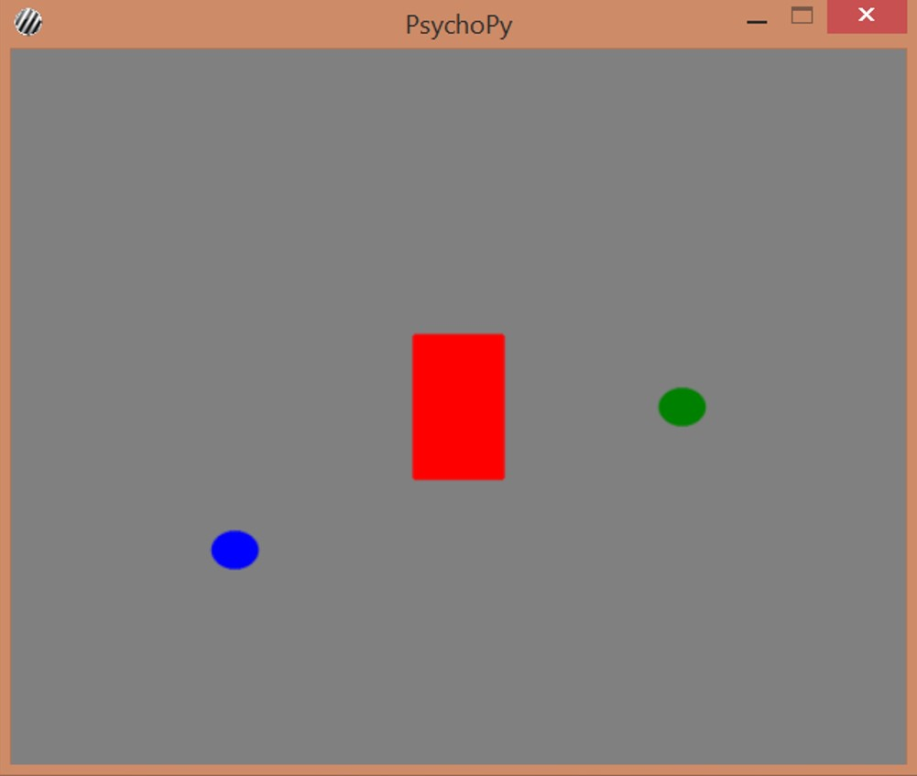

Finer details

Layout of the graphic elements:

● Use a screen of 500 (width) by 400 (height) pixels.

● In the center of the screen there is a wall with a thickness of 10% of the screen width and a height of 20% of the screen height.

● This wall has a red color.

● This wall does not move, of course.

● One car is blue and the other is green. You can represent a car as a (blue or green) sphere.

Driving cars:

● At the start of the trial, display the trial number for 0.5 seconds. After this announcement, the wall and the two cars (or spheres) appear on the screen.

● Both cars start vertically in the center of the screen. Horizontally, the blue car starts ¼ of the screen (left of center) and the green car starts ¾ of the screen (right of center).

● Each of the cars moves at a constant speed in horizontal and vertical directions. This means that at each time point the car moves randomly to the left or to the right (horizontal displacement), and at the same time randomly moves up or down (vertical displacement). The horizontal and vertical movement are made simultaneously, allowing the car to move diagonally. Hint: You can generate a random 0 or 1 via numpy.random.randint (0.2).

● The cars move in horizontal and vertical directions at a step size of 10% of the width and height of the screen, respectively.

● Each time step lasts 0.1 seconds.

● Make sure that the cars do not drive away from the screen. If they threaten to do so, their planned location must be brought back to the edge of the screen.

Collisions:

● A collision occurs when the center of a car hits the wall.

● Regarding the previous point: If you do not find how to test whether a car hits the wall, determine at random after each trial whether a collision took place and, if so, of which car.

● If no collision occurs within 10 seconds, start the next trial (5 trials in total).

● In the event of a collision, the trial ends and “Collision!” Appears. for 1 second on the screen.

● In the event of a collision, it must be recorded which of the two cars collided with the wall: the green or the blue?

End screen:

● At the end of the 5 trials, indicate which of the cars has crashed most often: "The blue one has crashed more often!" or "The green has collided more often!". It is also possible that they crashed the same number of times, and then "They crashed the same number of times!" to show up. However, if neither has ever collided, it should read "No collision!".

● This message will remain for 3 seconds and then the program will close.

Extra fancy addition:

● Download (small) green and blue cars and use them as stimuli instead of the spheres.